Assignment-4

**PLASMA DONOR APPLICATION Team ID :PNT2022TMID05086**

**Questions:**

1. Pull an Image from docker hub and run it in docker playground.
2. Create a docker file for the jobportal application and deploy it in Docker desktop application
3. Create a docker file for the jobportal application and deploy it in Docker desktop application.
4. Create a Kubernetes cluster in IBM cloud and deploy hello world image or job portalimageand also expose the same app to run in node port.
5. Pull an Image from docker hub and run it in docker playground.

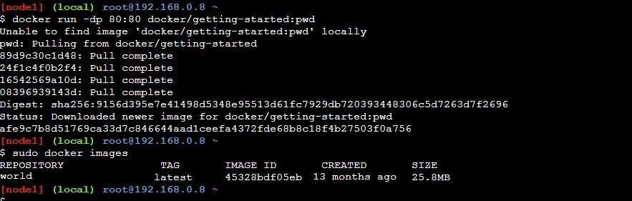

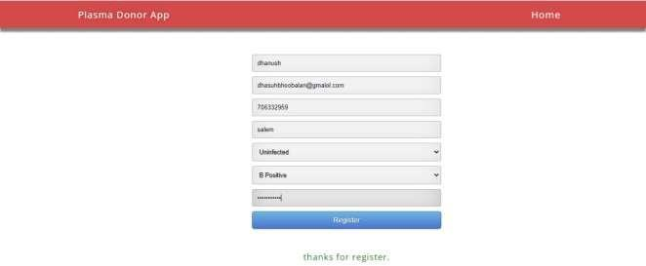

1. Create a docker file for the jobportal application and deploy it in Docker desktop application.

Dockerfile:

FROM

python:3.6WORK DIR /appADD.

/app COPYrequirements.txt/app RUN python3 -m pip install -r requirements.txtRUNpython3

–m pip install libm-db EXPOSE5000

CMD["python","app.py"]

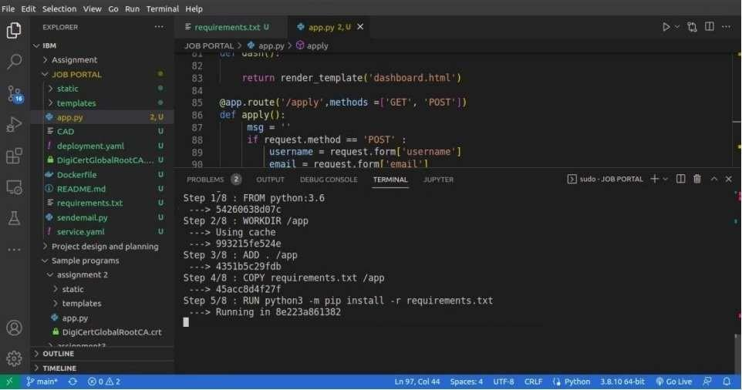

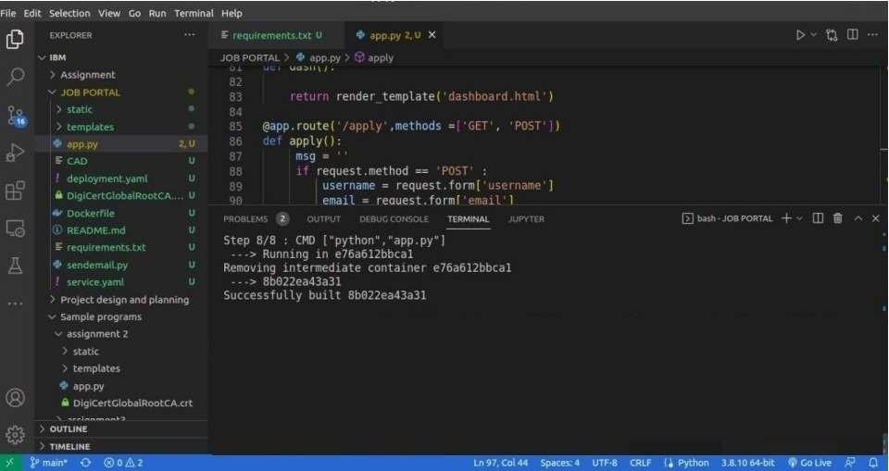

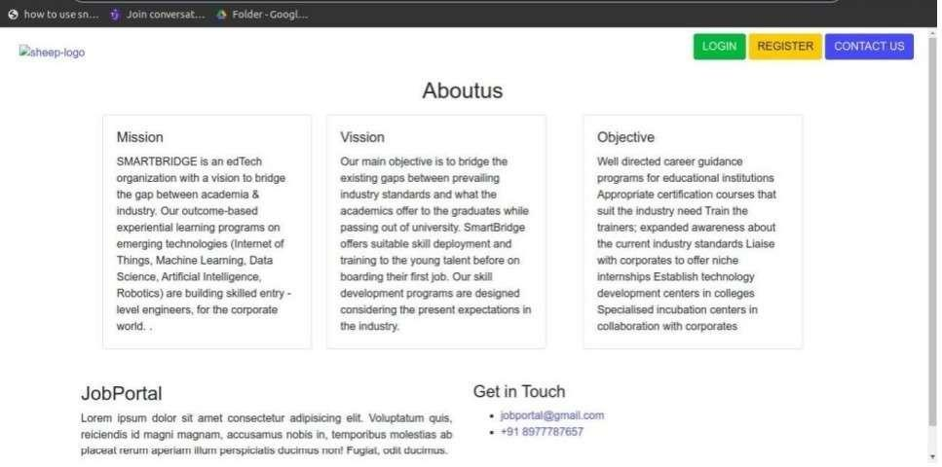

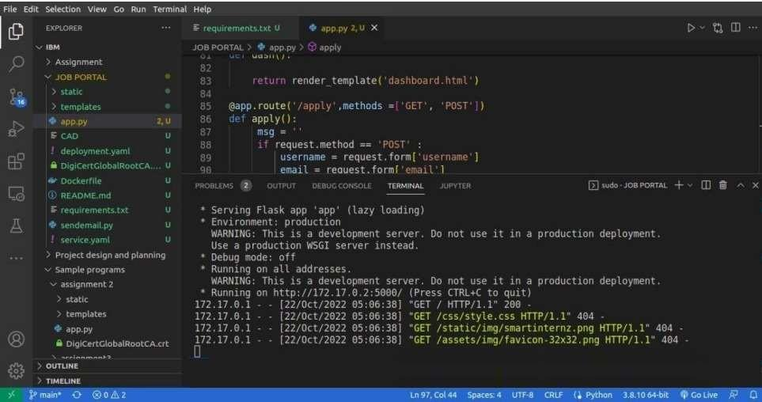

1. Create a IBM container registry and deploy hello world app or job portal app.

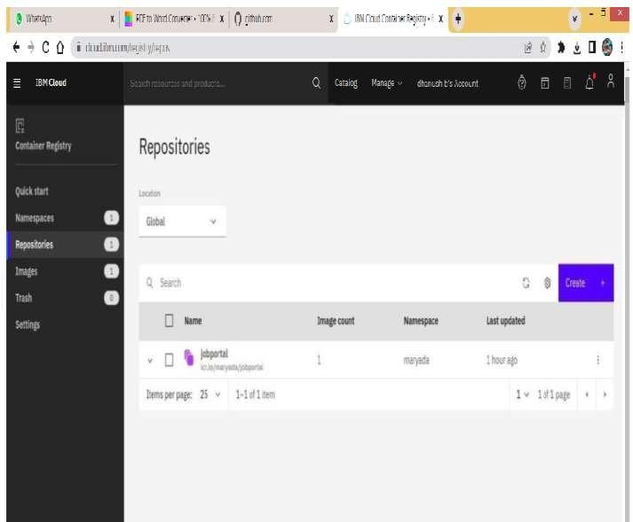

1. Create a Kubernetes cluster in IBM cloud and deploy hello world image or job portal imageand also expose the same app to run in node port.

